QRM with Block Quote
Two trades occuring instead of one, bug.
PITS 82693
Test Plan

Jesse Heit, Ext. 8746

Table of Contents
Problem Description – PITS 82693 3
Resolution 3
Test Verification Procedure 3

Problem Description – PITS 82693
When a block quote comes in and QRM is activated by a trade, it's possible for two trades to occur in 8.7 and earlier. In 8.8, this defect is fixed, where only one trade will occur.
One trade that activated QRM, and one additional trade before the quotes are cancelled. This PITS resolves that scenario. After QRM is started, no additional trades should occur with that user's quotes for that class.

Resolution
This has been resolved by setting the serverCommandQueue to 1 from 2 in both the
CommandProcessorImpl and
CommandProcessorComboQueueImpl classes.

Test Verification Procedure

Test Procedure:
Session, Class: W_MAIN, simple Options
On a SA GUI:
Open any class.
Two users are needed.
For user1, ensure QRM is not set.
For user2, set QRM for a class to volume: 10, seconds: 10, along with setting the "QRM enabled" box to checked.
See CIN2 (user2) in the example below.
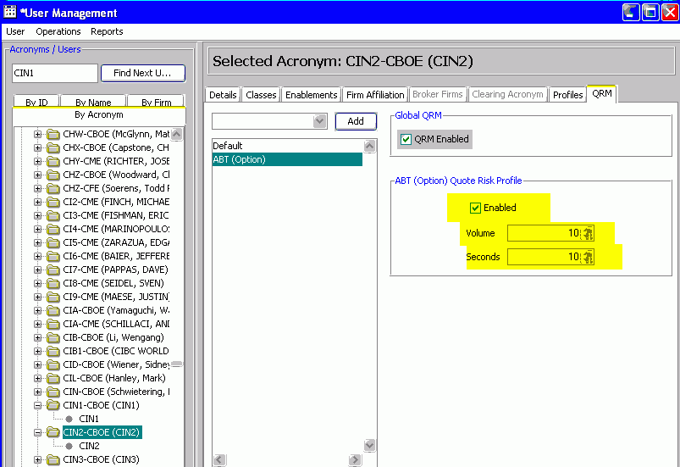

Verification:
Verify that
product is moved to ‘Open’
On Trader GUI:
Open a "Status Window" (Start, Status Window)

On the HybridTradeServerbox Host (e.g. atgqabc13)
The test will be run via idlTest.
Change the directory to the tmp directory.

Two idlTest scripts are needed with one script that'll trade against the other.
In one script, set the quotes to: 1.90 x 2.00, and setting the quotes to: 1.00 x 1.20 in the second script.

Easiest path, is to copy the following two scripts from:
/home/heitj/jess/addquotes/add4QuotesABTCIN1
/home/heitj/jess/addquotes/add4QuotesABTCIN2

Or create an idlTest script by copying the following lines.

In both cases, update the host name, Class Key, User name, and Product Keys.
(4 products from one class are needed.)

Script 1:

idlTest atgtest1BC03x1HybridTradeServer1 MarketMakerQuoteService acceptQuotesForClass 69206141 @${0}:p1
return

p1[0].quoteKey = 1
p1[0].productKey =1066413400
p1[0].sessionName = "W_MAIN"
p1[0].userId = "CIN1"
p1[0].bidPrice.type = 2
p1[0].bidPrice.whole = 1
p1[0].bidPrice.fraction = 900000000
p1[0].bidQuantity = 200
p1[0].askPrice.type = 2
p1[0].askPrice.whole = 2
p1[0].askPrice.fraction = 000000000
p1[0].askQuantity = 200
p1[0].transactionSequenceNumber = 0
p1[0].userAssignedId = "CIN1"

p1[1].quoteKey = 2
p1[1].productKey =1066413401
p1[1].sessionName = "W_MAIN"
p1[1].userId = "CIN1"
p1[1].bidPrice.type = 2
p1[1].bidPrice.whole = 1
p1[1].bidPrice.fraction = 900000000
p1[1].bidQuantity = 200
p1[1].askPrice.type = 2
p1[1].askPrice.whole = 2
p1[1].askPrice.fraction = 000000000
p1[1].askQuantity = 200
p1[1].transactionSequenceNumber = 0
p1[1].userAssignedId = "CIN1"

p1[2].quoteKey = 3
p1[2].productKey =1066413404
p1[2].sessionName = "W_MAIN"
p1[2].userId = "CIN1"
p1[2].bidPrice.type = 2
p1[2].bidPrice.whole = 1
p1[2].bidPrice.fraction = 900000000
p1[2].bidQuantity = 200
p1[2].askPrice.type = 2
p1[2].askPrice.whole = 2
p1[2].askPrice.fraction = 000000000
p1[2].askQuantity = 200
p1[2].transactionSequenceNumber = 0
p1[2].userAssignedId = "CIN1"

p1[3].quoteKey = 4
p1[3].productKey =1066413405
p1[3].sessionName = "W_MAIN"
p1[3].userId = "CIN1"
p1[3].bidPrice.type = 2
p1[3].bidPrice.whole = 1
p1[3].bidPrice.fraction = 900000000
p1[3].bidQuantity = 200
p1[3].askPrice.type = 2
p1[3].askPrice.whole = 2
p1[3].askPrice.fraction = 000000000
p1[3].askQuantity = 200
p1[3].transactionSequenceNumber = 0
p1[3].userAssignedId = "CIN1"

Script 2
idlTest atgtest1BC03x1HybridTradeServer1 MarketMakerQuoteService acceptQuotesForClass 69206141 @${0}:p1
return

p1[0].quoteKey = 1
p1[0].productKey =1066413400
p1[0].sessionName = "W_MAIN"
p1[0].userId = "CIN2"
p1[0].bidPrice.type = 2
p1[0].bidPrice.whole = 2
p1[0].bidPrice.fraction = 000000000
p1[0].bidQuantity = 100
p1[0].askPrice.type = 2
p1[0].askPrice.whole = 2
p1[0].askPrice.fraction = 100000000
p1[0].askQuantity = 200
p1[0].transactionSequenceNumber = 0
p1[0].userAssignedId = "CIN2"

p1[1].quoteKey = 2
p1[1].productKey =1066413401
p1[1].sessionName = "W_MAIN"
p1[1].userId = "CIN2"
p1[1].bidPrice.type = 2
p1[1].bidPrice.whole = 2
p1[1].bidPrice.fraction = 000000000
p1[1].bidQuantity = 140
p1[1].askPrice.type = 2
p1[1].askPrice.whole = 2
p1[1].askPrice.fraction = 100000000
p1[1].askQuantity = 200
p1[1].transactionSequenceNumber = 0
p1[1].userAssignedId = "CIN2"

p1[2].quoteKey = 3
p1[2].productKey =1066413404
p1[2].sessionName = "W_MAIN"
p1[2].userId = "CIN2"
p1[2].bidPrice.type = 2
p1[2].bidPrice.whole = 2
p1[2].bidPrice.fraction = 000000000
p1[2].bidQuantity = 130
p1[2].askPrice.type = 2
p1[2].askPrice.whole = 2
p1[2].askPrice.fraction = 100000000
p1[2].askQuantity = 200
p1[2].transactionSequenceNumber = 0
p1[2].userAssignedId = "CIN2"

p1[3].quoteKey = 4
p1[3].productKey =1066413405
p1[3].sessionName = "W_MAIN"
p1[3].userId = "CIN2"
p1[3].bidPrice.type = 2
p1[3].bidPrice.whole = 2
p1[3].bidPrice.fraction = 000000000
p1[3].bidQuantity = 200
p1[3].askPrice.type = 2
p1[3].askPrice.whole = 2
p1[3].askPrice.fraction = 100000000
p1[3].askQuantity = 200
p1[3].transactionSequenceNumber = 0
p1[3].userAssignedId = "CIN2"

Make both scripts executable
(enter chmod +x <script name 1>
(enter chmod +x <script name 2>

Execute both scripts. If both scripts are names: add4QuotesABTCIN1, add4QuotesABTCIN2
Enter both scripts names:
add4QuotesABTCIN1
add4QuotesABTCIN2
In the Status Window, verify that only one trade occurred.
Expected results: Only one trade occurred.

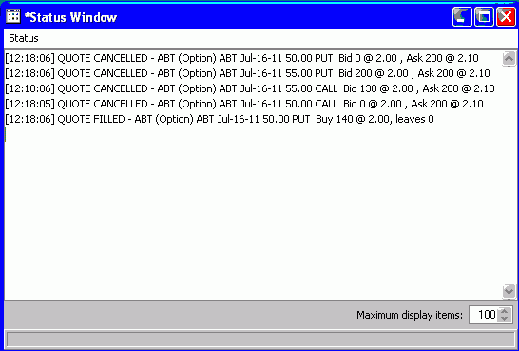
Unexpected results: Two trades occurred.

